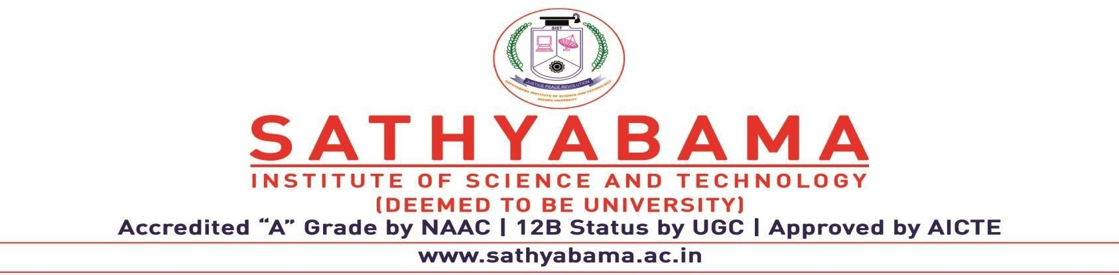

**CERTIFICATION OF APPRCIATEION**

This is to certify that Mr. **Hariharan B P** CSE student of Sathyabama Institute of Science and Technology (Registration No. 39110373) (Batch Id: 2019-23) has Developed project on **“Project Management and Maintenance”,** the project is developed based on the requirement from the Computer Science Department, to enable the faculty to track the status and completion of the project by the final year students.

The automatic project tracking and guide selection has been developed within the schedule time. The Department would like to place the appreciation for the quality of the project delivered.

Dr. T. Sasikala, M.E., Ph.D.

Dean School of Commuting

April 20, 2023



**CERTIFICATION OF APPRCIATEION**

This is to certify that Mr. **Mohnish Devaraj** CSE student of Sathyabama Institute of Science and Technology (Registration No. 39110636) (Batch Id: 2019-23) has Developed project on **“Project Management and Maintenance”,** the project is developed based on the requirement from the Computer Science Department, to enable the faculty to track the status and completion of the project by the final year students.

The automatic project tracking and guide selection has been developed within the schedule time. The Department would like to place the appreciation for the quality of the project delivered.

Dr. T. Sasikala, M.E., Ph.D.

Dean School of Commuting

April 20, 2023



**CERTIFICATION OF APPRCIATEION**

This is to certify that Mr. **Jagadeesh N** CSE student of Sathyabama Institute of Science and Technology (Registration No. 39110393) (Batch Id: 2019-23) has Developed project on **“Project Management and Maintenance”,** the project is developed based on the requirement from the Computer Science Department, to enable the faculty to track the status and completion of the project by the final year students.

The automatic project tracking and guide selection has been developed within the schedule time. The Department would like to place the appreciation for the quality of the project delivered.

Dr. T. Sasikala, M.E., Ph.D.

Dean School of Commuting

April 20, 2023